**Navigation Page**

Tuesday, 07 May 2024

Wednesday, 8 May 2024

Tuesday, 14 May 2024

Friday, 17 May 2024

Tuesday, 21 May 2024

Friday, 24 May 2024

Tuesday, 28 May 2024

Friday, 31 May 2024

Tuesday, 04 June 2024

Friday, 14 June 2024

Tuesday, 18 June 2024

Friday, 22 June 2024

07-05-2024

**Introduction to internet and World wide web**

It is necessary to know-

* Basis of it.
* Computer components and their functionalities.

**Terminologies**

1. Internet – It is a network of computers that are interconnected globally. We want to use the internet for communication and data transfer.
2. Protocol – It is a suite of instructions necessary or rules for communication over a network or internet.

The Internet is public while, network is specific.

1. Node – Any network device for e.g. Router, Modem, Desktop or mobile etc.

These are connected using ISP.

1. WWW – It stands for world wide web. It is space with combo of the recourses of internet that use HTTP.
2. Computer network – Interconnected computing devices for exchange of data and communication.

**Computer Architecture**

It kind of tells us how to build a PC. (Not the very real definition but at this level it is okay, will learn advance in CSCI 250).

Q: What are major computer components?

A: These are the components without which you cannot run the computer.

These are as follows:

1. RAM
2. CPU
3. Motherboard
4. Secondary Storage (e.g. SSD, HDD, CD, Tape)
5. PSU (Power Supply Unit)
6. GPU
7. I/O Device

**Cache**

It is the memory inside the CPU (Which is faster than RAM).

The hierarchy of speed –

Cache > RAM > Secondary Storage

Size trend goes larger from left to right. The Speed and Cost trend decreases from left to right.

Same goes for Cache Levels. L1 > L2 > L3 (Same speed, cost and size trends as above).

**Storage**

RAM – Stands for Random Access Memory. It is primary but temporary storage. It is faster than secondary storage.

ROM – Stands for Read Only Memory. It contains the sets of instructions necessary for system to boot and perform functions called BIOS.

Secondary storage types – 1. Magnetic 2. Tape

**PSU**

It stands for Power Supply Unit. It is basically a transformer which transforms AC current to DC current to computer system to make sure a smooth run.

8-05-2024

**History of the internet**

Main purpose of Computers?

* Calculating/Calculations

Name of the first computer?

* ENIAC (Electronic Numerical Integrator and calculator) around 1950 (exactly 1946). Main purpose was to perform calculations. It was 80 feet long and 8.5 feet high. It was around 7 million USD today. We need to connect all the wires together to perform the calculations. Too faster than human.

Sharing data was impossible or very hard in older times that’s why we wanted to create internet. Second reason was Cold war, the nuclear bomb would have destroyed everything, and they wanted to come up with solution (by contacting APARNET) to keep communication going even if everything was destroyed. Then they designed TCP protocol -> Idea was to connect the computers together by making a lot of connections with which if 2 nodes were destroyed, other nodes could still communicate.

Official first day od the internet was January 1, 1983. When lots of commercial companies came together to create network.

**WWW (World Wide Web)**

Tim Berners Lee invented first web using Hypertext to link the docs. First browser was called WorldWideWeb later renamed to as Nexus.

**Dot-Com Boom (1900s)**

It was characterized by the rapid growth of internet-based business. They invested in the internet infrastructure. Many dot-com companies failed.

**Broadband and Social Media**

Around 2000s they started to work on the broadband. They started using fibre channels to transfer data.

Social media platforms like Facebook, Netflix and YouTube etc. emerged as the internet speed rose.

**Mobile Internet,** **Cloud computing**

Mobile Internet became more powerful, we can do almost all tasks using it.

Cloud computing became easily available. It is like using Virtual computer.

**Network Types according to the size.**

WAN – Wide area network. This is connected to ISP (Internet service provider). Ties large wide area network. (Connected by TCP)

LAN – Local Area network. Our WIFI router will be connected to this port. (Connected by TCP)

International Network – Links system b/w countries.

**Network Topology**

We decide using this how to layout or connect or allocate the devices in the network (Physically or logically).

Types-

1. Point to point: When we must connect peripheral devices.
2. Star: When components of network are connected to a central point.

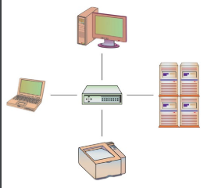

1. Bus – Components connected to the same cable.

1. Ring: Components connected in a closed loop.

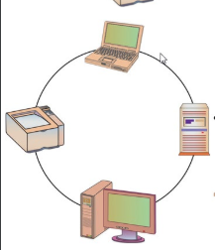

1. Mixed: Most popular one. Large networks such as office labs may use more than one type of topology.

**IP Address**

Internet address is controlled by Internet Protocol. It is like a phone number to contact a network.

**Packets**

Information is broken down into chunks called packets to pass it over a network. These are self-contained. Each packet has its own source address and destination address.

14-05-2024

**Protocols**

A set of rules for exchange or transmission of the information over the network. Most important to learn is HTTP and HTTPS. HTTPS is more secure because of encryption. The sending and receiving of data from server to user and vice versa is secure, no channel in b/w can view what data is interchanged. HTTP is not that secure. HTTP basically gets data of website from server and display to the user. Some content download faster so it displays faster and the one that is heavier will display later.

**Default ports used by protocols.**

HTTPs: 443

FTP: File transfer protocol 21

DNS: Domain Name System 53

SSH: Secure Shell 22

**Steps in handling a Client Request**

1. Obtain the IP from DNS
2. Request the Webpages or URLs from your browser (After you request an IP, a webpage and URL are requested form the webserver)
3. Read and parse the HTTP message (The recourses that we got from the server)
4. Convert URL to a name site.
5. Verify Authorization

**URL (Uniform resource locator)**

From the URL you can see the location of the file.

**Path Translation**

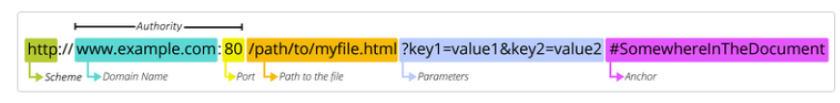

HTTP: Protocol  
80: Port number [Default port is 443 always]  
? to value2: Parameters  
/ to .html: Path to the file  
#: Anchor (Kind of direction or link or reference in the recourse such as a container)

Sample question to describe for mid-term -> <https://abc.com:8080>

**Web Stack**

It is set of software or services used for website development.

**HTML Basic Tag**

Progressive enhancement

1. HTML only: In the starting the html layer helps you to focus on importing things to your site.
2. CSS: It helps to improve readability of your website. It is separate file that keeps rules regarding how the webpage looks.
3. JavaScript: It is the behavioural layer, added at the end that brings life to important functions of your website.

HTML

Stands for Hyper text Markup Language. A markup language can tell the browser how to display the content (Not same as CSS). Markup can tell the structure of your content. HTML is not a programming language. It is set of a markup text such as <head><body><p><title> etc. It uses these texts to describe a webpage. It is the independent language as we do not need to use the compiler, it can run on any platform and web browser.

**HTML VS XML**

XML – eXtensible markup language. A text-based language used to describe and deliver structured information.  
  
HTML Terminology

**Tags:** It is surrounded by open and closed brackets ‘<>’. The content in between these brackets is known as tag name or tag.

**Elements:** The stuff that has start tag, content and an end tag is known as element. It can contain another element in it.

**Attributes:** It is something that provides additional knowledge or information about the contents of the elements. Generally, it provides the styling.

**HTML Document Structure**

1. <!DOCTYPE html>: This helps to recognize the version of the file or the code. It helps to recognize that your browser has to user HTML to display the content of this file.
2. <html>: Any content b/w this tag is the body of the HTML file. All tags in these are child tags <head> and <body>
3. <head>: It assists browser to display the content. <meta> tag in this tells browser to use UTF-8 encoding to decode the content of this file.
4. <body>: Anything to display should be between the body tags.
5. <footer>: We can add our social media links as this is the foot of our page.

17-05-2024

**Character Entities**

Less than - &lt

Greater than - &gt

Ampersand (&) - &amp

Go to page 3rd in ppt for all.

**HTML Lists**

Types:

1. Unordered –

* Uses a bullet point, or list marker before each entry in the list.

<ul> contains the unordered list.

<li> contains an item in the list.

Attribute types : disc, circle, square

1. Ordered –

* Uses Numbers or Romans or alphabets for serial numbers.

1. Description List –

* <dl> contains the description of the list.
* <dt> contains the term/phrase/sentence.
* <dd> Contains the description of the term/phrase/sentence/

Use ‘..’ to go out of the current folders.

Always use relative path and not absolute path.

21-05-2024

To create the header bar, we are going to use unordered list.

To practice the anchor, include lot of text to make your page bigger. So, you can test it or use it. We will use ‘id’ attribute to specify the id of the element so we can refer to it while using anchor tags.

**Table and Forms**

We need tables to store data in more organized forms and we use forms to collect the information or data form the user.

Tables include rows and columns.

Q. How to make a table?  
-> WE will use certain elements.

1. <table>: This is a closed tag that is used to start the table creation in html. Contents will be written row by row

2. <tr>: This indicates the start of each row.

3. <td>: Each cell is represented by td tag in table in html.

Use ctrl+/ to convert to comment (The one on numpad will not work).

How to remove the space in border? -> We use cell spacing.

How to add title? -> Use Caption tag

How to add background? -> use ‘background’ tag to add images, use ‘bgcolor’ to add colour the table background.

**Class Practice:**

<!DOCTYPE html>

<html lang="en">

<head>

<meta charset="UTF-8">

<meta name="viewport" content="width=device-width, initial-scale=1.0">

<title>Document</title>

</head>

<body>

<h2>Practice:</h2>

<br>

<table align="center" border="1px" cellspacing="1px" cellpadding="4px">

<caption style="padding-bottom: 4px;"><b>Race Results</b></caption>

<tr>

<th>Group</th>

<th>Runner</th>

<th>Time</th>

<th>Origin</th>

</tr>

<tr>

<td>Men</td>

<td>1. Peter Teagan</td>

<td>2:12:34</td>

<td>San Antonio, Texas</td>

</tr>

<tr>

<td>Men</td>

<td>2. Kyle Wills</td>

<td>2:13:05</td>

<td>Billings, Montana</td>

</tr>

<tr>

<td>Men</td>

<td>3. Jason Wu</td>

<td>2:14:28</td>

<td>Cutler, Colorado</td>

</tr>

<tr>

<td>Women</td>

<td>1. Laura Blake</td>

<td>2:28:21</td>

<td>Parl City, Colorado</td>

</tr>

<tr>

<td>Women</td>

<td>2. Kathy Lasker</td>

<td>2:30:11</td>

<td>Chicago, Illinois</td>

</tr>

<tr>

<td>Women</td>

<td>3. Lisa Peterson</td>

<td>2:31:14</td>

<td>Seattle, Washington</td>

</tr>

</table>

</body>

</html>

24-05-2024

Why are forms used?

* Log in to the app.

Submit a transaction.

Upload a file.

Etc.

We will use <form> tag for this. These can be sent using get or post method. The difference is when we use get method the values of the form are added to the end of the URL which is less secure and anyone watching your URL will come to know what you submitted, while, using the post method will send the values to the HTTP headers, more secure, also used when we want to send data in large amount.

Why do you want action attribute?

* This will tell us that who is in-charge of the data in the form, who wants the data in the form. Where we are sending the data through the form.

Why do we use method?

* It refers to the method of sending the data. Example: get, post, dialogue.

We need to add the name because when we submit the form to the server, we need to tell the server that what it is, and that will be contained in the name attribute.

User disabled attribute to disable changing the value. Use required attribute to make the field to be entered a compulsion.

**Class Demo:**

<!DOCTYPE html>

<html lang="en">

<head>

<meta charset="UTF-8">

<meta name="viewport" content="width=device-width, initial-scale=1.0">

<title>Document</title>

</head>

<body>

<h2>Display Radio Buttons</h2><br>

<label for="Language">Please select your favorite Web language:</label><br>

<br>

<input type="radio" name="Web language" id="Language" value="HTML">HTML <br>

<input type="radio" name="Web language" id="Language" value="CSS">CSS <br>

<input type="radio" name="Web language" id="Language" value="Javascript">Javascript <br>

</body>

</html>

28-05-2024

Always provide meaningful name.

We have ‘value’ to let the server know what user have chosen in radio button or checkbox.

We use ‘id’ for identification as we need to refer the element in the future in Java script or to other part of the code.

How to make ‘iframe’?

* Design different pages for top and bottom. Use to format ‘<iframe src=”page.html”>’ you can also use attributes such as height, width, style etc.

31-05-2024

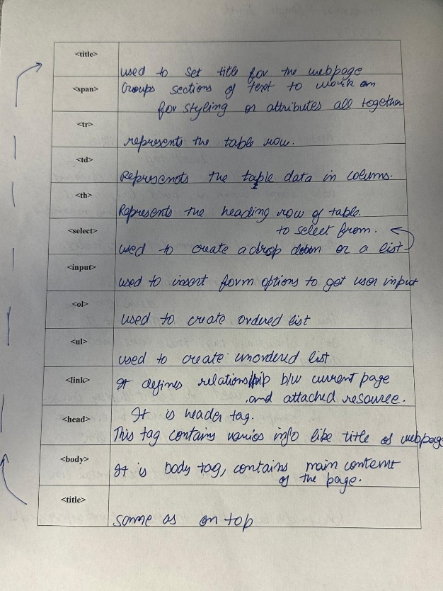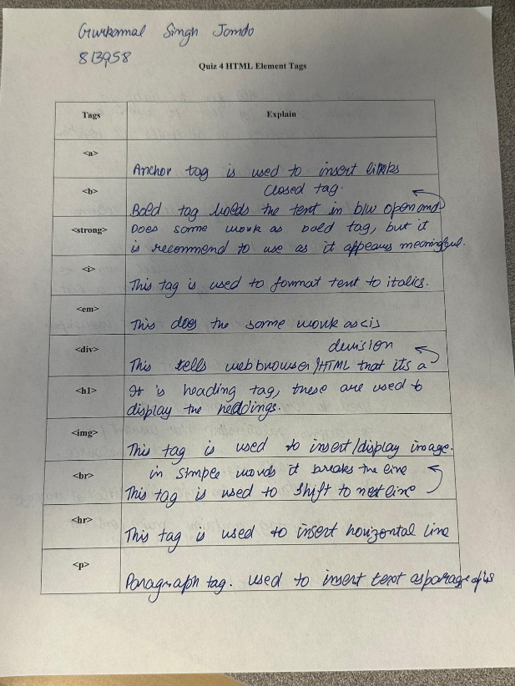**CLASS ACTIVITY**

**Intro to CSS**

HTML is for content structure only, but CSS will help adding styles to it.

It helps us:

* Add formatting to make it more stylish and eye-catching.
* Add specific layout styles according to screen size.
* Animate page contents (like changing colour, movement, etc.).

We can use Java Script to add animations but always try to use CSS as downloading java code will only increase CPU usage which will make your page inefficient.

**Styles**

There are three styles:

1. Inline style –

It might be used to apply a unique style to a single element. To use it, add the style attribute to the relevant element. Preferred inly to use if we want to modify single line.

Pros: It can be quick and easy to see the change made.

Cons: It makes the code layout messy and make the indentation look not so good. It can be quite confusing for others if you are working with a group of developers if we have a lot of content. If we have multiple similar content, we got to individually add styles to each of it if we use this kind of styling.

2. External CSS style <link> -

We need to use this when we are working with multiple webpages of one website. <link> tag can be used to attach the HTML document to the external style file. It should be in the ‘head’ tag. This is beneficial because we can apply it to as many webpages as we want without just rewriting the whole styles code of copying and pasting it in the head of all pages.  
eg. <link rel="stylesheet" href="CSS/style.css" type="CSS">

3. Internal CSS style <style> -

Including the CSS rules within the same code as HTML but in separate tag under head element (Place them within style tag under head tag).

****Class is not unique, so if we want to apply style to multiple content, so we are going to use class.

**CSS Selectors**

There are different types of selectors:

1. Type selectors: Uses the name of the tag to refer for styling.

2. Class Selectors: Use the class name to refer for styling. Use ‘.’ In front of class name in your style sheet.

3. ID Selectors: references the id name attribute of any element for styling.

4. Universal Selectors: uses “*” which uses to affect many different elements. (*{style code in this})

5. Attribute Selectors: matches the element based on the presence or value of the given attribute.

04-06-2024

6. Pseudo-class selectors – uses pseudo-classes to apply the styles. E.g. “:link”, “:visited”

These are used to define a special state of an element.

We can also combine different selectors, but we need to **separate them using comma**.

**REMEMBER:** Inline style has a higher priority than any internal or link style. Inline>Internal>external.

**Combinators**

* Descendant selectors (space): Selects the descendants of a specified element.
* Child Selectors (>): Selects the direct children.
* Adjacent Selectors (+): Selects the next sibling immediately beside the tag.
* General Sibling Selectors (~): Selects all the child elements.

These are used to define a relationship b/w the selectors. Above the four main types.

7. Mixed element selectors – We can use multiple types of selectors to combine them and apply styles to nested. Putting space is not suggested.

15-06-2024

**Box Model**

The box model is basically a box layout that wraps around every html element. Each element is represented by a rectangular box.

Content: It is the content of the element/box. Can be text or image etc.

Padding: It is the space between the content and the border

Border: It goes around the content and the padding

Margin: Areas occupied outside the border.

Margin

Content

Padding

Content

Padding

Border

Border

**Border**

Basically, we have top, right, bottom and left border also while managing them in CSS we need to follow the same order in applying styles to them. (We need to work on them clockwise)

Most used attributes are border colour, width, style, which can be used as border-top-width.

**Margin**

This property is used to create spaces around the elements outside the borders of it. We can use either margin as whole to evenly add space or we can edit the space on left, right etc. using ‘margin-left’.

18-06-2024

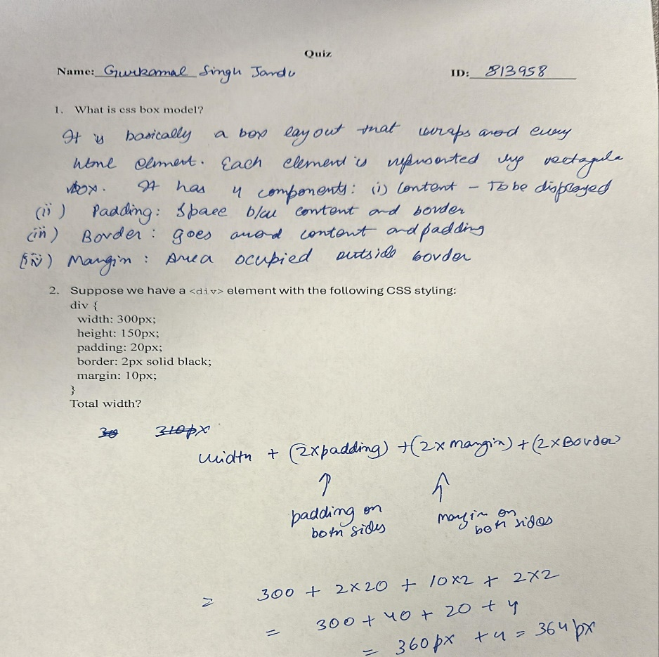

**JavaScript**

Introduction –

A scripting (we don’t need to use compilers) language (lightweight programming language) which can be inserted in HTML and can be executed by all the modern web browsers.

How to include it in your code?

* Using <script> </script> or using <script src="app.js"></script>.

What is Variable?

* These are temporary memory location or containers for storing values.

**Declaring Variables**

Syntax: variable keyword = variable value; note: ‘=’ is assignment operator. If we do not provide any value java script will consider it undefined.

Let: Re-declaring not allowed. Only limited to the block they are in or assigned to.

Const: This is a constant value; we cannot modify it.

Var: Re-declaring allowed. These need to be at the top of the code and are function scooped. If it is outside function, it become the global variable.

22-06-2024

**Arithmetic Operators**

* + Add
* - Subtract
* * Multiply
* / Divide
* % Modulus (remainder)

**if/else**

if statement used to execute the block of JavaScript code if the condition is true.

*Syntax:*

if (condition) {

// Block of code to be executed if the condition is true

} else {

// Block of code to be executed if the condition is false

}

**Data Types**

* int (integer): whole numbers like 0, 1, 2, 3
* float (floating-point): decimal numbers
* boolean: true or false

{NaN: Not a Number}

**Comments**

Comments are not part of the code. These are for understanding the code.

* Single-line comment: // comment
* Multi-line comment: /* comment */

**Operators**

* = is the assignment operator.
* == is the equality operator.

**Example:**

let a = 5; // number  
let b = "5"; // string  
console.log (a == b); // true  
console.log (a === b); // false  
console.log (a + b); // "55"  
console.log (a * b); // 25